717-331-9033
gabsaboard@gmail.com
PO BOX 125 Greencastle, PA 17225

GABSA Softball Operating Manual
2024

VISION | Page 3
ORGANIZATION AND OPERATING GUIDELINES | Page 4
SEASONAL SCHEDULE | Page 5
RESIDENCY REQUIREMENTS/LEAGUE BOUNDARY | Page 6-7
REGISTRATION | Page 8
AGE CHART | Page 9-10
LEVELS OF COMPETITION | Page 11-12
REGULAR SEASON COACHES | Page 13
PLAYER SELECTION PROCEDURES | Page 14

I: VISION
The mission of GABSA Fastpitch Softball is to mold our teams into not only great athletes, but also great young women. It also is our goal to help create memories that will last these young women throughout their lifetime. GABSA Fastpitch Softball provides a safe and competitive environment for young players to learn and enjoy the game of fast-pitch softball. GABSA Fastpitch Softball was established for the dual purpose of developing a quality recreational program for players from Greencastle. Dedicated coaches and volunteers will facilitate our athletes’ growth through stepwise development of softball skills, instilling core life values of character, integrity, confidence, self-esteem and sportsmanship. Our teams will promote our values both on and off the field. On the field, we will strive to do our best while, off the field, we will strive to be an outstanding community citizen. In all situations, we will represent GABSA Fastpitch Softball and the community with the utmost respect.

II: ORGANIZATION AND OPERATING GUIDELINES
- Organization:
  - Greencastle Softball Little League is organized under the Greencastle Antrim Baseball/Softball Association (GABSA).

  - GABSA Fastpitch Softball will be governed by Chairpersons appointed and approved by the Greencastle Antrim Baseball/Softball Association each year.

  - GABSA Softball League Chairperson are responsible for the following:
    - Managers
    - All Protests and Problems
    - Game Scheduling and Field Practices
    - Rescheduling Postponed Games
    - Organization Registration
    - League Meetings
    - All-Star Games

  - The League is chartered by Little League® Softball in District 14.
- Operating Guidelines
  - GABSA and Little League® Softball rules, regulations, and operations apply except as amended herein.

  - This manual addresses all softball divisions Minor, Major, and Senior of the League.

  - The League directors will review/revise this manual annually or as necessary.

  - Based on expected returning players and new League registrations, the League currently plans to field 3 Minor Teams, 3 Major Teams, and 1 Senior Team.

  - Team names will be based on sponsorships.

III: SEASONAL SCHEDULE

Registration | December-Early February
Player Selection | Early March
Team Practices Begin | Early-Mid March
Regular Softball Little League Season Games Begin | April 8th
Opening Day | April 8th
Regular Softball Little League Season Games End | End of May
*Must play 8 Little League Softball Games to be tournament eligible in Minors and Majors.

IV: RESIDENCY REQUIREMENTS/LEAGUE BOUNDARY

According to the Little League Website:
Each local Little League determines the actual geographic boundaries of the area from within which it shall select players. These boundaries must be described in detail and shown on a map and dated when making application for a Little League charter. Players will be eligible to play with that league only if they reside, or the physical location of the school where they attend classes, is within the boundaries provided to and approved by Little League Baseball, Incorporated.
- A player will be deemed to reside within the league boundaries if:
  - His/her parents are living together and are residing within such league boundaries, OR;
  - Either of the player’s parents (or his/her court-appointed legal guardian) reside within such boundaries. It is unacceptable if a parent moves into a league’s boundaries for the purpose of qualifying for tournament play. As detailed later in these rules, the penalty for violation of this rule may, in Little League Baseball, Incorporated’s discretion, result in the disqualification of a player, team or entire league from regular season and/or tournament play.
  - Residence,” “reside” and “residing” refers to a place of bonafide continuous habitation. A place of residence once established shall not be considered changed unless the parents, parent or guardian makes a bonafide change of residence.

Residence shall be established and supported by documents containing the full residence which includes parent(s) or guardian(s) name, street address, city, state and zip code information, dated or in force between February 1 of the previous year and February 1 of the current year, from one or more documents from EACH of the three Groups outlined below:

Group I
- Driver’s License
- School Records
- Vehicle Records (i.e., Registration, Lease, etc.)
- Employment Records
- Insurance Documents

Group II
- Welfare/Child Care Records
- Federal Records (i.e., Federal Tax, Social Security, etc.)
- State Records
- Local (Municipal) Records
- Support Payment Records
- Homeowner or Tenant Records
- Military Records

Group III
- Voter’s Registration
- Utility Bills (i.e., Gas, Electric, Water/Sewer, Phone, Heating, Waste Disposal)
- Financial Records
- Medical Records
- Internet, Cable, or Satellite Records

IMPORTANT NOTE: Example – Three documents from the same Group (utility bill, cable bill, and bank statement) constitute only ONE document. Players who established “residence” or “school attendance” for regular season and/or tournament prior to the 2016-2017 season using the Player Verification Form and can produce the form with proper proofs and signatures, will be grandfathered and will NOT need to complete a new Player Verification Form.
Any documents submitted as proof of residence must show customary usage or consumption to demonstrate bonafide continuous habitation as determined by Little League Baseball, Incorporated in its discretion.

A player will be deemed to attend school in the boundaries if: The physical location of the school where they attend classes is within the boundaries established by the local league. Note: This excludes home schools, cyber schools, sports-related schools, sports academies, or preschool or after school where a student participates outside of the primary school the player is enrolled.

“School attendance” refers to the (place) physical location the player in question attends school during the traditional academic year. Once established, a location of school attendance shall not be considered changed unless the child is enrolled and attends another school or is no longer enrolled in the previous school.

School attendance shall be established and supported by a document indicating enrollment for the current academic year, dated prior to October 1 of the current year and with the physical location of the school, from ONE of the following categories to determine school attendance by such player:
- Official/Certified School enrollment record
- The Little League-issued school attendance form completed by the principal, assistant principal, or administrator.
It is recommended that the league require some proof of residence or school attendance within the league’s boundaries at the time the player registers. Players and their parents/guardians are advised that a false statement of residence or school attendance may lead to ineligibility to play Little League Baseball or Softball.

Greencastle Little League consists of all of Antrim, Montgomery, Warren, Peters, & Saint Thomas Townships, inclusive of Greencastle & Mercersburg Boroughs, as well as portions of Hamilton Township, Guilford Township, and Chambersburg Borough, located in Franklin County Pennsylvania.
Please reference… https://www.littleleague.org/play-little-league/league-finder/ to find our boundary map. Use the address 451 W. Washington St Greencastle PA 17225

V: REGISTRATION
- Parent or legal guardian can register their child at http://gabsa.org/ OR
- At Scheduled in Person Registration which dates can be found on http://gabsa.org/
- Payment is required at registration.
- League Participants may be required to participate in various fundraisers throughout the season.

VI: AGE CHART
- The Age Determination Date for a Little League Softball Player is the actual age of a child on December 31st of previous year.
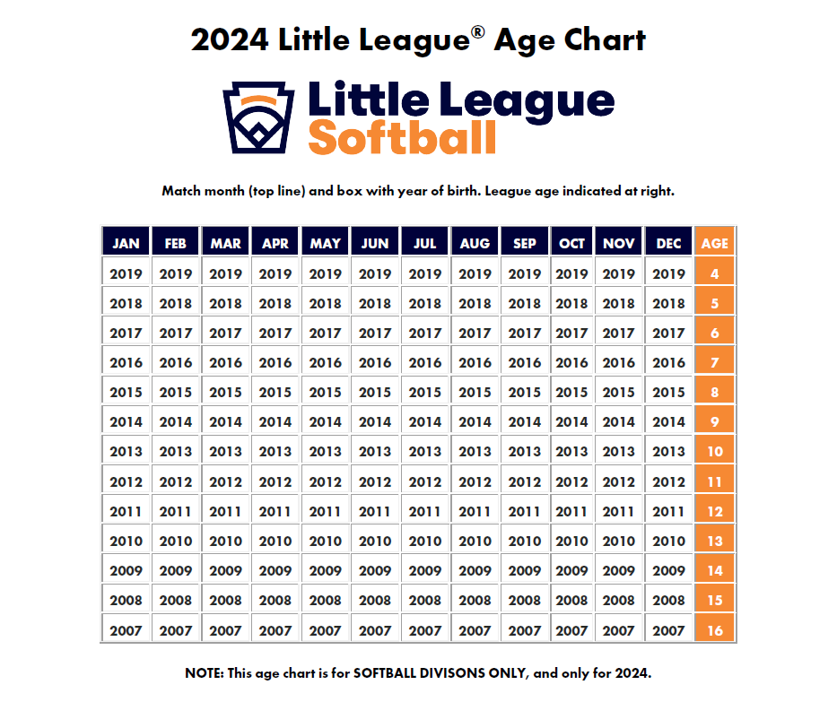
*Players will be moved to a division either up or down at the discretion of the league chairs/directors according to safety, numbers, and what is deemed best for the league.

Tee Ball
- Players who are league age 4-7 are eligible to be selected to a Tee Ball Team
Minors
- Players who are league age 7-9 are eligible to be selected to a Minor League Division (Coach and Player Pitch) team.
Majors
- Players who are league age 9-12 are eligible to be selected to a Little League (“Major”) Division team for the regular season. The local league board of directors may restrict this division to players who are league age 10-12 or 11-12
Seniors
- Players who are league age 12-16 are eligible to be selected to a Senior League Division team for the regular season. The local league board of directors may decide to have different age-cutoff for this division, provided it is within the grouping noted.

*Those who are not included among the league ages listed above are not eligible for any softball division in Little League for the current season.

VII: LEVELS OF COMPETITION
GABSA Fastpitch Softball competes in the following leagues:
1. Softball Little League follows Softball Little League Rules
- Tee Ball Softball is for girls 4-5 years old (with a local option for 6- and/or 7-year-olds) who want to learn the fundamentals of hitting and fielding. In Tee Ball Softball, players hit a ball off a batting tee. Rules of the game may be varied to accommodate the need for teaching and should focus on fun, fitness, and fundamentals. The primary goals of Tee Ball Softball are to instruct children in the fundamentals of softball and to allow them to experience the value of teamwork. There is no minimum or maximum composition for Tee Ball rosters, but we would recommend smaller roster sizes to help keep all players engaged. No live pitching is permitted in this division. Generally, the diamond used is a 60-foot diamond, but the league has the option to use a 50-foot diamond. Parents are strongly encouraged to become involved as managers, coaches, and volunteer in a variety of other capacities. For additional Little League Tee Ball resources visit LittleLeague.org/TeeBall.
- Minor League Softball is for participants 5-11 years old and can be operated with multiple divisions that are based on age and/or ability. Divisions may include “machine pitch,” “coach pitch” and “player pitch.” By local option, a player who is league age 5 or 6 for the current season and has played a year in Tee Ball is eligible for the coach pitch or machine pitch minor divisions. A local league might organize its 7-8-year-olds in the Coach Pitch Division and its 9-10-year-olds in the Player Pitch division; however, by local option, some of the 9-year-olds could “play down” in the coach pitch division, and some of the 8-year-olds could “play up.” This is entirely the choice of the local league board of directors. (League age 12-year-olds may participate in the Minor Division under certain circumstances.) There is no minimum or maximum composition for rosters, but most leagues have rosters in the 8-12 range. Competitive divisions of Minor League Softball may only use nine players on defense. The diamond has 60-foot base paths and a 35 foot pitching distance. Parents are strongly encouraged to become involved as managers, coaches, and volunteer in a variety of other capacities.
  - Local League Rules: Minors teams will be able to field 10 players (4 outfielders)
    - All Star Teams will field 9 (3 outfielders)
  - Minor league will do a combined coach and player pitch. Kid pitch will be innings 2,4,6. Coaches will take over pitching in those innings if the pitcher has walked 3 players in the inning.
  - Minor league will cap innings 1-5 to 5 runs. The 6th inning will have no cap.
  - Minor league will honor the following run rules:
    - 15 after 3, 10 after 4, 8 after 5
  - Minor league is allowed to steal all bases except home. They can leave the base once the pitch has reached the batter.
- Little League (Major Division). The Little League Softball® division (sometimes known as the Major Division) is for players ages 9-12. A local league may choose to limit its Major Division to 10-, 11- and 12-year-olds, or 11-12-year-olds. The field uses a 60-foot diamond and a 40 foot pitching distance. A local league may dual-roster 12-year-olds, assessed capable, to a Major and a Junior division softball team. The local league has an option to choose a Tournament Team (or “All Stars”) of 10-to-12-year-olds from within this division, and the team may enter the International Tournament. The culmination of the International Tournament is the Girls Little League Softball World Series, featuring teams from around the world. All expenses for the teams advancing to the World Series (travel, meals, and housing) are paid by Little League International. Parents are strongly encouraged to become involved as managers, coaches, and volunteer in a variety of other capacities.
IMPORTANT: A local league must only have ONE Major Division. For instance, if the local league has all 11–12-year-olds in the Majors, and all 9-10s in another division, then the 9-10s MUST be chartered an play a Minor Division.
- Senior Division: The Senior League Softball Division is for girls 13-16 years old, using a 60-foot diamond with a pitching distance of 43 feet. The local league has an option to choose a Tournament Team (or “All Stars”) of 13-16-year-olds from within this division (and/or from within the Junior League Softball divisions), and the team may enter the International Tournament. The culmination of the International Tournament is the Senior League Softball World Series, featuring teams from around the world. All expenses for the teams advancing to the World Series (travel, meals and housing) are paid by Little League International.

*Please refer to the following website for softball little league rules: https://www.littleleague.org/playing-rules/ or you can download the Little League Rulebook APP

VIII: REGULAR SEASON COACHES
- The GABSA Board of Directors will approve all regular season coaches.
- Individuals interested in coaching a League team must contact a League director or member of the GABSA board no later than February.
- If there are more candidates than coaching positions available, the coaches will be decided by a majority vote of the Little League Committee and approved by the GABSA Board.
- Coaches are not guaranteed the same team from year-to-year.
- All coaches shall conduct themselves in a sportsman like manner at all times. Failure to do so could lead to dismissal as manager.
- Coaches’ responsibilities are as followed:
  - Be in control of their players, coaches, and their fans always.
  - Appoint a team Mother/Father
  - Support all fundraisers conducted by the association.
  - Cover all team concession stand assignments.
  - Assist on all scheduled field clean-up days.
  - Cleanup the dugout area after all games and practices.
  - Be responsible for all league equipment and uniforms.

IX: PLAYER SELECTION PROCEDURES

***Evaluations for GABSA Fastpitch Softball will take place if the numbers call for two or more teams***

