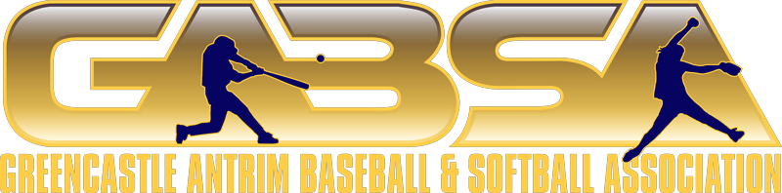

**Meeting Minutes – August 11, 2024**

**Call to Order** – 6pm

**Members Present:** Bob Martin, Bill Sperry, Doug Mongan, Jason Mills, Nick Kempen, Kurt Kline, Jesse Duffey, Cheyenne Kempen, Zack Barkdoll, Irvin Sleighter, Chelsey Sleighter, Holly Duffey, Chris Bonillas, Kevin Brashears, Andy Lewis, Jordan Reitz, Rodney Rose

**Members Absent:** Erin Ullom, Austin Luckenbaugh, Bobby Lowery, Bob Kinback, Shannon Myers, Derrick Horst, Dan Monn

**Quorum: Yes No**

**Approve the Agenda:**

* Agenda Approved: Jesse Duffey Motioned, Nick Kempen seconded. All approved

**Guests**: No Guest.

**Approval of the Minutes:**

* Minutes: Attendance update (Gabe F needs to move to absent) – amendment needed for July Minutes. Jason Mills motioned; Jesse Duffey seconded. All approved.

**Approval of Treasurer’s Report:**

* June and July sent out. Nick Kempen motioned; Jesse Duffey seconded. All approved.
* How much would it cost for an audit?

**New Board Members:**

* None this time

**Old Business:**

* Fall Ball:
  + Baseball numbers look good for 1 Rookie, 2 Minor, 1 Major. Softball at 1 Minor and 1 Major currently.
  + Need to open softball to 16 years old rather than 14.
  + Committee to come up with umpire decision and let board know for vote.
* Batting Cage (Horst):
  + Holly to reach to JLG contact on putting up the cage by October 25th. Will ask if they will provide all the equipment to complete this. Answer by August 25th; if not answer.
  + Old batting cage needs torn: Saturday the 17th @ 8am
    - Irvin, Doug, Holly, Kurt, Nick, Chey, Jesse, Chris, plus two volunteer boys to assist in other areas.
* Clary (Grass Infield)
  + Plan to begin with the committee, project starting on September 22nd. Current budget up to date, equipment rentals and other materials will begin.
* Golf Tournament
  + 4 Hole sponsors to date.
  + Need to communicate more about being a sponsor.
  + Reminder each member is responsible for getting a hole sponsor by 9/8/24
    - $100.00, includes Ad at hole plus business cards.
    - $200.00 Ad at hole, business cards, and custom t for swag bag
    - $300.00 all the above and a custom ball marker
    - $500.00 Event sponsor – all the above plus what specialty item added.

**League Reports:**

* Baseball/Softball – Reports
  + 8U Allstars won their 1st ever Clarence Boyd Tournament!

**Committee Reports:**

* **Membership Committee:** Welcome new members
  + Current attendance reviewed with the board.
* **Project & Finance Committee:** 
  + QuickBooks: reviewed during the treasurer report. Creating a financial report for the whole year to review and then a proposed budget to review.
* **Sponsorship Committee**:
  + Three sponsors outstanding: Cunningham’s, other two Rodney will follow up with.
  + Plan submitted to review options: Bill to share with executive board.
  + Update from BJs that everything is going up %15-%20
  + Jenna sent mass letter to local businesses for current projects available for sponsorship.
* **Facilities and Grounds Committee**:
  + Field mix washed down.
  + Need to share a list of items that need done before Fall Ball and KOTC
* **GABSA Planning Committee:**
  + Nothing currently.
* **Concession Stand Committee:**
  + Inventory and cleanup day.
  + Holly and Chey to work in concession stand on Saturday.
* **Tournament Committee:**
  + Fall KOTC Dates: Sept 14-15 9u, 11u, 13u. Sept 21-22 10u, 12u, 14u.
  + Fall Ball Teams to cover concessions during this.
  + Registration is open (currently 4 teams registered, will pick up)
  + Signups will occur next meeting 9/8.

**New Business:**

* **Assistant Treasurer:** Nominate and vote.
  + Bill nominated Chelsey Sleighter for Asst. Treasurer. Rodney Rose seconds. All approved.
* October 13th is structure meeting for the year. Attendance is crucial. Please plan to attend and be thinking abut what positions and/or committees you are interested in.
* Insurance Coverage: Will continue to have executive board coverage.
* Pool Party for All Stars:
  + Saturday the 24th between 2p-5p. We donate $50.00 (Irvin to pay). All approved.

**Open Floor:** Floor open for discussion on new topics.

* Sponsorship for Golf:
  + Souders Bat’s: Fungo and hole sponsor – Mills will contact.
* Golf Tournament:
  + October 5th All Day
    - Committee to come up with roles that need filled for volunteers.

**Adjournment: 8:54pm**

**Next Board Meeting**

* September 8th, 2024 @ 6:00 PM @ JAPH